Topic: Azure CDN
Azure Content Delivery Network (CDN) is a global CDN solution for delivering high-bandwidth content. It can be hosted in Azure or any other location. With Azure CDN, you can cache static objects loaded from Azure Blob storage, a web application, or any publicly accessible web server, by using the closest point of presence (POP) server. Azure CDN can also accelerate dynamic content, which cannot be cached, by leveraging various network and routing optimizations.
A content delivery network (CDN) is a distributed network of servers that can efficiently deliver web content to users. CDNs' store cached content on edge servers in point-of-presence (POP) locations that are close to end users, to minimize latency.
The benefits of using Azure CDN to deliver web site assets include:
- Better performance and improved user experience for end users, especially when using applications in which multiple round-trips are required to load content.
- Large scaling to better handle instantaneous high loads, such as the start of a product launch event.
- Distribution of user requests and serving of content directly from edge servers so that less traffic is sent to the origin server.
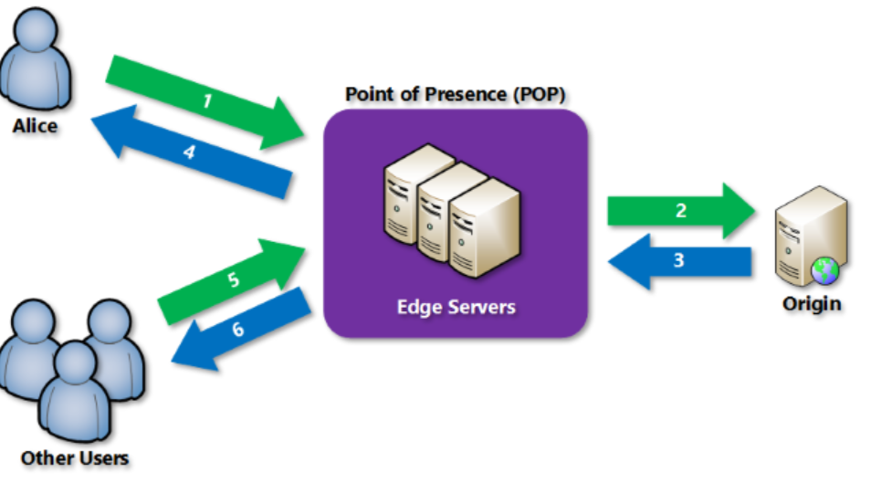
Azure CDN offers the following key features:
- Dynamic site acceleration
- CDN caching rules
- HTTPS custom domain support
- Azure diagnostics logs
- File compression
- Geo-filtering

To use Azure CDN, you must own at least one Azure subscription. You also need to create at least one CDN profile, which is a collection of CDN endpoints.

Integrate an Azure Storage account with Azure CDN

Create a storage account

Enable Azure CDN for the storage account
In the New endpoint section, enter the following information : CDN profile , CDN endpoint name , Origin hostname
cdn-endpoint-123.azureedge.net

Enable additional CDN features
From the storage account Azure CDN page, select the CDN endpoint from the list to open the CDN endpoint configuration page.
From this page, you can enable additional CDN features for your delivery, such as compression, query string caching, and geo filtering.
To access cached content on the CDN, use the CDN URL provided in the portal. The address for a cached blob has the following format:
http://<endpoint-name>.azureedge.net/<myPublicContainer>/<BlobName>

Remove content from Azure CDN
If you no longer want to cache an object in Azure CDN, you can take one of the following steps:
- Make the container private instead of public. For more information, see Manage anonymous read access to containers and blobs.
- Disable or delete the CDN endpoint by using the Azure portal.
- Modify your hosted service to no longer respond to requests for the ob

Add Azure CDN to an Azure App Service web app

Create the web app

Dynamic site acceleration optimization

If you want to optimize your CDN endpoint for dynamic site acceleration (DSA), you should use the CDN portal to create your profile and endpoint. With DSA optimization, the performance of web pages with dynamic content is measurably improved. For instructions about how to optimize a CDN endpoint for DSA from the CDN portal, see CDN endpoint configuration to accelerate delivery of dynamic files. Otherwise, if you don't want to optimize your new endpoint, you can use the web app portal to create it by following the steps in the next section. Note that for Azure CDN from Verizon profiles, you cannot change the optimization of a CDN endpoint after it has been created.
In the App Service page, in the Settings section, select Networking > Configure Azure CDN for your app.
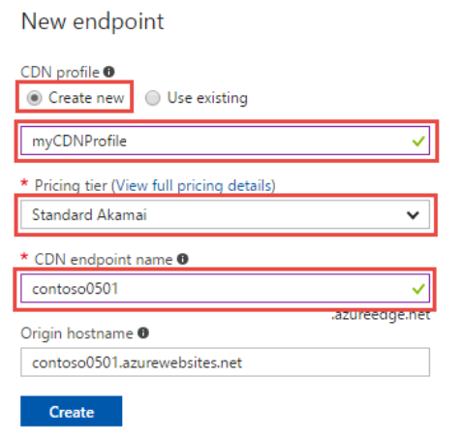
For the CDN to reflect the new changes in the file , we need to Purge the end point , hence to reflect the changed content

Dynamic site acceleration

With the explosion of social media, electronic commerce, and the hyper-personalized web, a rapidly increasing percentage of the content served to end users is generated in real time.
Azure CDN from Akamai and Azure CDN from Verizon both offer DSA optimization through the Optimized for menu during endpoint creation. Dynamic site acceleration from Microsoft is offered via Azure Front Door Service.

CDN endpoint configuration to accelerate delivery of dynamic files

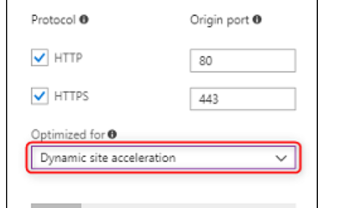

DSA Optimization using Azure CDN
Dynamic Site Acceleration on Azure CDN speeds up delivery of dynamic assets by using the following techniques:
- Route optimization
- TCP optimizations
- Object prefetch (Azure CDN from Akamai only)
- Adaptive image compression (Azure CDN from Akamai only)

Route Optimization
Route optimization is important because the Internet is a dynamic place, where traffic and temporarily outages are constantly changing the network topology. The Border Gateway Protocol (BGP) is the routing protocol of the Internet, but there may be faster routes via intermediary Point of Presence (PoP) servers.
Route optimization chooses the most optimal path to the origin so that a site is continuously accessible and dynamic content is delivered to end users via the fastest and most reliable route possible.

TCP Optimizations
Transmission Control Protocol (TCP) is the standard of the Internet protocol suite used to deliver information between applications on an IP network. By default, several back-and-forth requests are required to set up a TCP connection, as well as limits to avoid network congestions

Object prefetch (Azure CDN from Akamai only)
Prefetch is a technique to retrieve images and scripts embedded in the HTML page while the HTML is served to the browser, and before the browser even makes these object requests.

Adaptive image compression (Azure CDN from Akamai only)
Some devices, especially mobile ones, experience slower network speeds from time to time. In these scenarios, it is more beneficial for the user to receive smaller images in their webpage more quickly rather than waiting a long time for full resolution images.
With DSA, caching is turned off by default on the CDN, even when the origin includes Cache-Control or Expires headers in the response.

Control Azure CDN caching behavior with caching rules

- Caching rules: This article describes how you can use content delivery network (CDN) caching rules to set or modify default cache expiration behavior both globally and with custom conditions, such as a URL path and file extension. Azure CDN provides two types of caching rules:
  - Global caching rules: You can set one global caching rule for each endpoint in your profile, which affects all requests to the endpoint. The global caching rule overrides any HTTP cache-directive headers, if set.
  - Custom caching rules: You can set one or more custom caching rules for each endpoint in your profile. Custom caching rules match specific paths and file extensions, are processed in order, and override the global caching rule, if set.
- Query string caching: You can adjust how the Azure CDN treats caching for requests with query strings. For information, see Control Azure CDN caching behavior with query strings. If the file is not cacheable, the query string caching setting has no effect, based on caching rules and CDN default behaviors.
- Bypass cache: Do not cache and ignore origin-provided cache-directive headers.
- Override: Ignore origin-provided cache duration; use the provided cache duration instead. This will not override cache-control: no-cache.
- Set if missing: Honor origin-provided cache-directive headers, if they exist; otherwise, use the provided cache duration.

Custom caching rules match conditions
For custom cache rules, two match conditions are available:
- Path: This condition matches the path of the URL, excluding the domain name, and supports the wildcard symbol (*). For example, /myfile.html, /my/folder/*, and /my/images/*.jpg. The maximum length is 260 characters.
- Extension: This condition matches the file extension of the requested file. You can provide a list of comma-separated file extensions to match. For example, .jpg, .mp3, or .png. The maximum number of extensions is 50 and the maximum number of characters per extension is 16.

Global and custom rule processing order
Global and custom caching rules are processed in the following order:
- Global caching rules take precedence over the default CDN caching behavior (HTTP cache-directive header settings).
- Custom caching rules take precedence over global caching rules, where they apply. Custom caching rules are processed in order from top to bottom. That is, if a request matches both conditions, rules at the bottom of the list take precedence over rules at the top of the list. Therefore, you should place more specific rules lower in the list.

Configure HTTPS on an Azure CDN custom domain

Some of the key attributes of the custom HTTPS feature are:
- No extra cost: There aren't costs for certificate acquisition or renewal and no extra cost for HTTPS traffic. You pay only for GB egress from the CDN.
- Simple enablement: One-click provisioning is available from the Azure portal. You can also use REST API or other developer tools to enable the feature.
- Complete certificate management is available:
  - All certificate procurement and management is handled for you.
  - Certificates are automatically provisioned and renewed before expiration.

Diagnostic logs - Azure Content Delivery Network

With Azure diagnostic logs, you can view core analytics and save them into one or more destinations including:
- Azure Storage account
- Log Analytics workspace
- Azure Event Hubs
This feature is available on CDN endpoints for all pricing tiers.
Diagnostics logs allow you to export basic usage metrics from your CDN endpoint to different kinds sources so that you can consume them in a customized way. You can do the following types of data export:
- Export data to blob storage, export to CSV, and generate graphs in Excel.
- Export data to Event Hubs and correlate with data from other Azure services.
- Export data to Azure Monitor logs and view data in your own Log Analytics workspace

Improve performance by compressing files in Azure CDN

There are two ways to enable file compression:
- Enable compression on your origin server. In this case, Azure CDN passes along the compressed files and delivers them to clients that request them.
- Enable compression directly on the CDN POP servers (compression on the fly). In this case, the CDN compresses the files and serves them to the end users, even if they were not compressed by the origin server.

Restrict Azure CDN content by country/region

When a user requests your content, the content is served to users in all locations. You may want to restrict access to your content by country/region.
With the geo-filtering feature, you can create rules on specific paths on your CDN endpoint. You can set the rules to allow or block content in selected countries/regions.
# Create a CDN profile.
az cdn profile create --resource-group MyResourceGroup --name MyCDNProfile --sku Standard_Microsoft

# Create a CDN endpoint.
az cdn endpoint create --resource-group MyResourceGroup --name MyCDNEndpoint --profile-name MyCDNProfile --origin www.contoso.com

# Create an origin group.
az cdn origin-group create --resource-group MyResourceGroup --endpoint-name MyCDNEndpoint --profile-name MyCDNProfile --name MyOriginGroup --origins origin-0

# Make the origin group the default group of an endpoint.
az cdn endpoint update --resource-group MyResourceGroup --name MyCDNEndpoint --profile-name MyCDNProfile --default-origin-group MyOriginGroup

# Create another origin for an endpoint.
az cdn origin create --resource-group MyResourceGroup --endpoint-name MyCDNEndpoint --profile-name MyCDNProfile --name origin-1 --host-name example.contoso.com

Azure CDN Standard from Microsoft profiles supports the following optimizations:
- General web delivery. This optimization is also used for media streaming and large file download.

Azure CDN Standard from Verizon and Azure CDN Premium from Verizon profiles support the following optimizations:
- General web delivery. This optimization is also used for media streaming and large file download.
- Dynamic site acceleration
Azure CDN Standard from Akamai profiles support the following optimizations:
- General web delivery
- General media streaming
- Video-on-demand media streaming
- Large file download
- Dynamic site acceleration

- # Create a new profile
- New-AzCdnProfile -ProfileName CdnPoshDemo -ResourceGroupName CdnDemoRG -Sku Standard_Akamai -Location "Central US"

- # Create a new endpoint
- New-AzCdnEndpoint -ProfileName CdnPoshDemo -ResourceGroupName CdnDemoRG -Location "Central US" -EndpointName cdnposhdoc -OriginName "Contoso" -OriginHostName "www.contoso.com"

- # Create a new profile and endpoint (same as above) in one line
- New-AzCdnProfile -ProfileName CdnPoshDemo -ResourceGroupName CdnDemoRG -Sku Standard_Akamai -Location "Central US" | New-AzCdnEndpoint -EndpointName cdnposhdoc -OriginName "Contoso" -OriginHostName "www.contoso.com"

# Get an existing endpoint
$endpoint = Get-AzCdnEndpoint -ProfileName CdnPoshDemo -ResourceGroupName CdnDemoRG -EndpointName cdnposhdoc

# Set up content compression
$endpoint.IsCompressionEnabled = $true
$endpoint.ContentTypesToCompress = "text/javascript","text/css","application/json"

# Save the changed endpoint and apply the changes
Set-AzCdnEndpoint -CdnEndpoint $endpoint
# Purge some assets.
Unpublish-AzCdnEndpointContent -ProfileName CdnDemo -ResourceGroupName CdnDemoRG -EndpointName cdndocdemo -PurgeContent "/images/kitten.png","/video/rickroll.mp4"

# Pre-load some assets.
Publish-AzCdnEndpointContent -ProfileName CdnDemo -ResourceGroupName CdnDemoRG -EndpointName cdndocdemo -LoadContent "/images/kitten.png","/video/rickroll.mp4"

# Purge everything in /images/ on all endpoints.
Get-AzCdnProfile | Get-AzCdnEndpoint | Unpublish-AzCdnEndpointContent -PurgeContent "/images/*"

# Remove a single endpoint
Remove-AzCdnEndpoint -ProfileName CdnPoshDemo -ResourceGroupName CdnDemoRG -EndpointName cdnposhdoc

# Remove all the endpoints on a profile and skip confirmation (-Force)
Get-AzCdnProfile -ProfileName CdnPoshDemo -ResourceGroupName CdnDemoRG | Get-AzCdnEndpoint | Remove-AzCdnEndpoint -Force

# Remove a single profile
Remove-AzCdnProfile -ProfileName CdnPoshDemo -ResourceGroupName CdnDemoRG

Manage expiration of web content in Azure CDN

Files from publicly accessible origin web servers can be cached in Azure Content Delivery Network (CDN) until their time-to-live (TTL) elapses. The TTL is determined by the Cache-Control header in the HTTP response from the origin server. This article describes how to set Cache-Control headers for the Web Apps feature of Microsoft Azure App Service, Azure Cloud Services, ASP.NET applications, and Internet Information Services (IIS) sites, all of which are configured similarly. You can set the Cache-Control header either by using configuration files or programmatically.
You can choose to set no TTL on a file. In this case, Azure CDN automatically applies a default TTL of seven days, unless you've set up caching rules in the Azure portal. This default TTL applies only to general web delivery optimizations. For large file optimizations, the default TTL is one day, and for media streaming optimizations, the default TTL is one year.

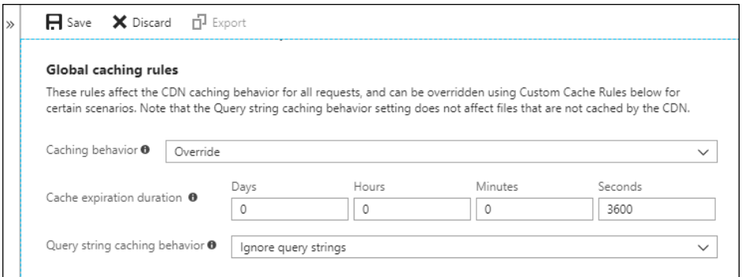

Securing Azure CDN assets with token authentication

This is a feature of Azure CDN Premium from Verizon only, to configure rules on Azure CDN from Microsoft please use the Standard rules engine. Advanced rules are not available for Azure CDN from Akamai. For a full comparison of CDN features, see Azure CDN product features.

Token authentication is a mechanism that allows you to prevent the Azure Content Delivery Network (CDN) from serving assets to unauthorized clients. Token authentication is typically done to prevent hotlinking of content, in which a different website, such as a message board, uses your assets without permission. Hotlinking can have an impact on your content delivery costs. By enabling token authentication on CDN, requests are authenticated by CDN edge server before the CDN delivers the content.

Failover across multiple endpoints with Azure Traffic Manager

Azure Cache for Redis

Azure Cache for Redis provides an in-memory data store based on the Redis software. Redis improves the performance and scalability of an application that uses backend data stores heavily. It's able to process large volumes of application requests by keeping frequently accessed data in the server memory, which can be written to and read from quickly. Redis brings a critical low-latency and high-throughput data storage solution to modern applications.
Azure Cache for Redis improves application performance by supporting common application architecture patterns. Some of the most common include the following patterns:
Data cache | Databases are often too large to load directly into a cache. It's common to use the cache-aside pattern to load data into the cache only as needed. When the system makes changes to the data, the system can also update the cache, which is then distributed to other clients. Additionally, the system can set an expiration on data, or use an eviction policy to trigger data updates into the cache.

Content cache | Many web pages are generated from templates that use static content such as headers, footers, banners. These static items shouldn't change often. Using an in-memory cache provides quick access to static content compared to backend datastores. This pattern reduces processing time and server load, allowing web servers to be more responsive. It can allow you to reduce the number of servers needed to handle loads. Azure Cache for Redis provides the Redis Output Cache Provider to support this pattern with ASP.NET.
Session store | This pattern is commonly used with shopping carts and other user history data that a web application might associate with user cookies. Storing too much in a cookie can have a negative effect on performance as the cookie size grows and is passed and validated with every request. A typical solution uses the cookie as a key to query the data in a database. Using an in-memory cache, like Azure Cache for Redis, to associate information with a user is much faster than interacting with a full relational database.
Job and message queuing | Applications often add tasks to a queue when the operations associated with the request take time to execute. Longer running operations are queued to be processed in sequence, often by another server. This method of deferring work is called task queuing. Azure Cache for Redis provides a distributed queue to enable this pattern in your application.
Distributed transactions | Applications sometimes require a series of commands against a backend data-store to execute as a single atomic operation. All commands must succeed, or all must be rolled back to the initial state. Azure Cache for Redis supports executing a batch of commands as a single transaction.

Basic | An OSS Redis cache running on a single VM. This tier has no service-level agreement (SLA) and is ideal for development/test and non-critical workloads.
Standard | An OSS Redis cache running on two VMs in a replicated configuration.
Premium | High-performance OSS Redis caches. This tier offers higher throughput, lower latency, better availability, and more features. Premium caches are deployed on more powerful VMs compared to the VMs for Basic or Standard caches.
Enterprise | High-performance caches powered by Redis Labs' Redis Enterprise software. This tier supports Redis modules including RediSearch, RedisBloom, and RedisTimeSeries. Also, it offers even higher availability than the Premium tier.
Enterprise Flash | Cost-effective large caches powered by Redis Labs' Redis Enterprise software. This tier extends Redis data storage to non-volatile memory, which is cheaper than DRAM, on a VM. It reduces the overall per-GB memory cost.

Choosing the right tier

Memory , Performance , Dedicated core for Redis server , Network performance , Maximum number of client connections , High availability , Data persistence , Network isolation , Redis Modules
You can scale your cache from the Basic tier up to Premium after it has been created. Scaling down to a lower tier isn't supported currently.

Create an open-source Redis cache (Basic)

Database Azure Cache for Redis
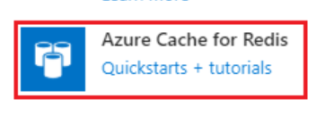

Create a Redis Enterprise cache

Azure Cache for Redis' Enterprise tiers provide fully integrated and managed Redis Enterprise on Azure. These new tiers are:
- Enterprise, which uses volatile memory (DRAM) on a virtual machine to store data
- Enterprise Flash, which uses both volatile and non-volatile memory (NVMe or SSD) to store data.
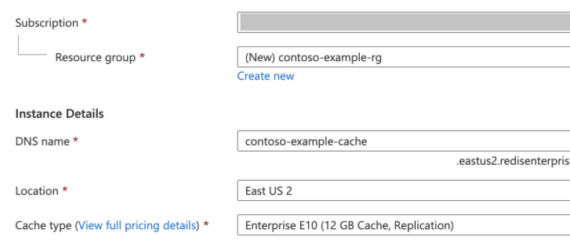

Use Azure Cache for Redis with an ASP.NET web app

Retrieve host name, ports, and access keys from the Azure portal
To connect to an Azure Cache for Redis instance, cache clients need the host name, ports, and a key for the cache. Some clients might refer to these items by slightly different names. You can get the host name, ports, and keys from the Azure portal.
<appSettings>
<add key="CacheConnection" value="<cache-name>.redis.cache.windows.net,abortConnect=false,ssl=true,allowAdmin=true,password=<access-key>"/>
</appSettings>
Install-Package StackExchange.Redis
IDatabase cache = GetDatabase();
ViewBag.command1 = "PING";
ViewBag.command1Result = cache.Execute(ViewBag.command1).ToString();

// Simple get and put of integral data types into the cache
ViewBag.command2 = "GET Message";
ViewBag.command2Result = cache.StringGet("Message").ToString();

ASP.NET Core APP
dotnet add package StackExchange.Redis

ASP.NET Session State Provider for Azure Cache for Redis

Install-Package Microsoft.Web.RedisSessionStateProvider
<sessionState mode="Custom" customProvider="MySessionStateStore">
<providers>
<add name="MySessionStateStore" type="Microsoft.Web.Redis.RedisSessionStateProvider"
host=""
accessKey=""
ssl="true" />
</providers>
</sessionState>
<!--
<add name="MySessionStateStore"
host = "127.0.0.1" [String]
port = "" [number]
accessKey = "" [String]
ssl = "false" [true|false]
throwOnError = "true" [true|false]
retryTimeoutInMilliseconds = "5000" [number]
databaseId = "0" [number]
applicationName = "" [String]
connectionTimeoutInMilliseconds = "5000" [number]
operationTimeoutInMilliseconds = "1000" [number]
connectionString = "<Valid StackExchange.Redis connection string>" [String]
settingsClassName = "<Assembly qualified class name that contains settings method specified below. Which basically return 'connectionString' value>" [String]
settingsMethodName = "<Settings method should be defined in settingsClass. It should be public, static, does not take any parameters and should have a return type of 'String', which is basically 'connectionString' value.>" [String]
loggingClassName = "<Assembly qualified class name that contains logging method specified below>" [String]
loggingMethodName = "<Logging method should be defined in loggingClass. It should be public, static, does not take any parameters and should have a return type of System.IO.TextWriter.>" [String]
redisSerializerType = "<Assembly qualified class name that implements Microsoft.Web.Redis.ISerializer>" [String]
/>
-->

ASP.NET Output Cache Provider for Azure Cache for Redis

Install-Package Microsoft.Web.RedisOutputCacheProvider
<caching>
<outputCache defaultProvider="MyRedisOutputCache">
<providers>
<add name="MyRedisOutputCache" type="Microsoft.Web.Redis.RedisOutputCacheProvider"
host=""
accessKey=""
ssl="true" />
</providers>
</outputCache>
</caching>
<connectionStrings>
<add name="MyRedisConnectionString" connectionString="mycache.redis.cache.windows.net:6380,password=actual access key,ssl=True,abortConnect=False" />
</connectionStrings>
<sessionState mode="Custom" customProvider="MySessionStateStore">
<providers>
<add type = "Microsoft.Web.Redis.RedisSessionStateProvide"
name = "MySessionStateStore"
connectionString = "MyRedisConnectionString"/>
</providers>
</sessionState>

<%@ OutputCache Duration="60" VaryByParam="*" %>

Azure Event Grid is an eventing service for the cloud. In this quickstart, you'll use the Azure portal to create an Azure Cache for Redis instance, subscribe to events for that instance, trigger an event, and view the results. Typically, you send events to an endpoint that processes the event data and takes actions. However, to simplify this quickstart, you'll send events to a web app that will collect and display the messages.
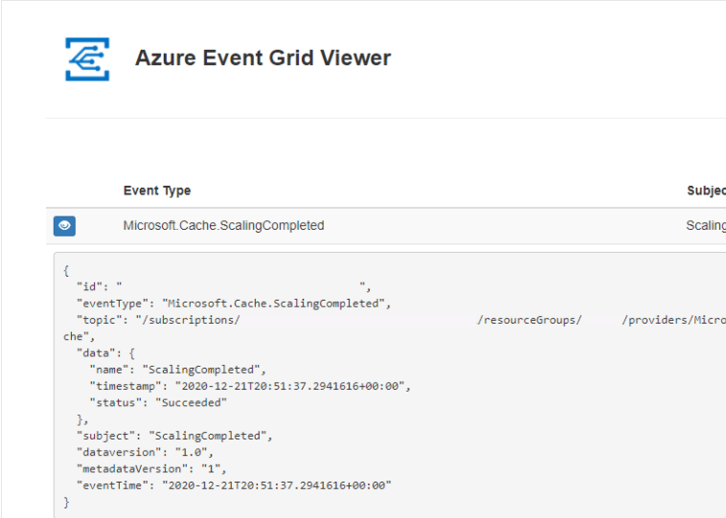

az provider register --namespace Microsoft.EventGrid
az provider show --namespace Microsoft.EventGrid --query "registrationState"

cacheId=$(az redis show --name <cache_name> --resource-group <resource_group_name> --query id --subscription <subscription_id>)
endpoint=https://$sitename.azurewebsites.net/api/updates

az eventgrid event-subscription create \
--source-resource-id $cacheId \
--name <event_subscription_name> \
--endpoint $endpoint
IDatabase cache = Connection.GetDatabase();

Scripts

# Create a Resource Group
az group create --name contosoGroup --location eastus

# Create a Basic C0 (256 MB) Redis Cache
az redis create --name contosoCache --resource-group contosoGroup --location eastus --sku Basic --vm-size C0

Create a Premium Azure Cache for Redis with clustering

# Create a Resource Group
az group create --name contosoGroup --location eastus

# Create a Premium P1 (6 GB) Redis Cache with clustering enabled and 2 shards (for a total of 12 GB)
az redis create --name contosoCache --resource-group contosoGroup --location eastus --vm-size P1 --sku Premium --shard-count 2

High availability for Azure Cache for Redis

Azure Cache for Redis has built-in high availability. A high availability architecture is used to ensure your managed Redis instance is functioning even when outages affect the underlying virtual machines (VMs), both planned and unplanned outages. It delivers much greater percentage rates than what's attainable by hosting Redis on a single VM.
Azure Cache for Redis implements high availability by using multiple VMs, called nodes, for a cache. The nodes are configured such that data replication and failover happen in coordinated manners. High availability also aids in maintenance operations such as Redis software patching. Various high availability options are available in the Standard, Premium, and Enterprise tiers
Standard replication | Dual-node replicated configuration in a single datacenter with automatic failover | 99.9% (see details) | ✔ | ✔ | -
Zone redundancy | Multi-node replicated configuration across AZs, with automatic failover | Up to 99.99% (see details) | - | ✔ | ✔
Geo-replication | Linked cache instances in two regions, with user-controlled failover | Up to 99.999% (see details) | - | ✔ | Preview

Best practices for Azure Cache for Redis

Use Standard or Premium tier for production systems.
Remember that Redis is an in-memory data store
Develop your system such that it can handle connection blips because of patching and failover
Configure your maxmemory-reserved setting to improve system responsiveness
Redis works best with smaller values, so consider chopping up bigger data into multiple keys.
Locate your cache instance and your application in the same region. Connecting to a cache in a different region can significantly increase latency and reduce reliability.
Reuse connections. Creating new connections is expensive and increases latency, so reuse connections as much as possible. If you choose to create new connections, make sure to close the old connections before you release them
Use pipelining. Try to choose a Redis client that supports Redis pipelining. Pipelining helps make efficient use of the network and get the best throughput possible.
Configure your client library to use a connect timeout of at least 15 seconds, giving the system time to connect even under higher CPU conditions
Avoid expensive operations - Some Redis operations, like the KEYS command, are very expensive and should be avoided. For more information, see some considerations around long-running commands
Idle Timeout - Azure Cache for Redis currently has 10-minute idle timeout for connections, so your setting should be to less than 10 minutes.

Configure Redis clustering for a Premium Azure Cache for Redis instance

Azure Cache for Redis offers Redis cluster as implemented in Redis. With Redis Cluster, you get the following benefits:
- The ability to automatically split your dataset among multiple nodes.
- The ability to continue operations when a subset of the nodes is experiencing failures or are unable to communicate with the rest of the cluster.
- More throughput: Throughput increases linearly as you increase the number of shards.
- More memory size: Increases linearly as you increase the number of shards.
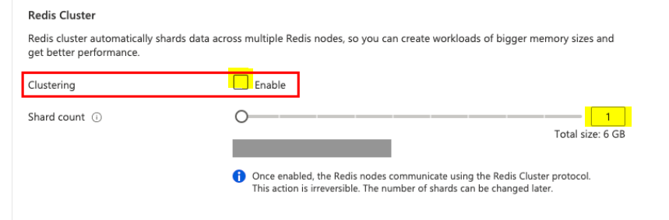

You can have up to 10 shards in the cluster. After selecting Enable, slide the slider or type a number between 1 and 10 for Shard count and select OK.
Each shard is a primary/replica cache pair managed by Azure, and the total size of the cache is calculated by multiplying the number of shards by the cache size selected in the pricing tier.
The largest premium cache size is 120 GB. You can create up to 10 shards giving you a maximum size of 1.2 TB.

Many clients support Redis clustering but not all. Check the documentation for the library you're using to verify you're using a library and version that support clustering.

Configure data persistence for a Premium Azure Cache for Redis instance

Azure Cache for Redis offers Redis persistence using the Redis database (RDB) and Append only File (AOF):
- RDB persistence - When you use RDB persistence, Azure Cache for Redis persists a snapshot of the Azure Cache for Redis in a Redis to disk in binary format. The snapshot is saved in an Azure Storage account. The configurable backup frequency determines how often to persist the snapshot. If a catastrophic event occurs that disables both the primary and replica cache, the cache is reconstructed using the most recent snapshot. Learn more about the advantages and disadvantages of RDB persistence.
- AOF persistence - When you use AOF persistence, Azure Cache for Redis saves every write operation to a log. The log is saved at least once per second into an Azure Storage account. If a catastrophic event occurs that disables both the primary and replica cache, the cache is reconstructed using the stored write operations. Learn more about the advantages and disadvantages of AOF persistence.

- In the Advanced tab for a premium cache instance, configure the settings for non-TLS port, clustering, and data persistence. For data persistence, you can choose either RDB or AOF persistence.

Add replicas to Azure Cache for Redis

Azure Cache for Redis Standard and Premium tiers offer redundancy by hosting each cache on two dedicated virtual machines (VMs). These VMs are configured as primary and replica. When the primary VM becomes unavailable, the replica detects that and takes over as the new primary automatically

Secure your cache with a Virtual Network

Azure Virtual Network deployment provides enhanced security and isolation along with: subnets, access control policies, and other features to restrict access further. When an Azure Cache for Redis instance is configured with a virtual network, it isn't publicly addressable. Instead, the instance can only be accessed from virtual machines and applications within the virtual network.

Azure Cache for Redis with Azure Private Link

Application Insights

Application Insights, a feature of Azure Monitor, is an extensible Application Performance Management (APM) service for developers and DevOps professionals. Use it to monitor your live applications.

It will automatically detect performance anomalies, and includes powerful analytics tools to help you diagnose issues and to understand what users actually do with your app.

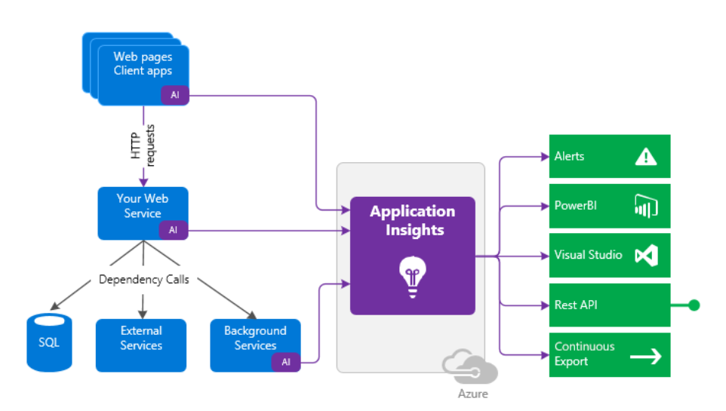

What does Application Insights monitor?

- Request rates, response times, and failure rates - Find out which pages are most popular, at what times of day, and where your users are. See which pages perform best. If your response times and failure rates go high when there are more requests, then perhaps you have a resourcing problem.
- Dependency rates, response times, and failure rates - Find out whether external services are slowing you down.
- Exceptions - Analyze the aggregated statistics, or pick specific instances and drill into the stack trace and related requests. Both server and browser exceptions are reported.
- Page views and load performance - reported by your users' browsers.
- AJAX calls from web pages - rates, response times, and failure rates.
- User and session counts.
- Performance counters from your Windows or Linux server machines, such as CPU, memory, and network usage.
- Host diagnostics from Docker or Azure.
- Diagnostic trace logs from your app - so that you can correlate trace events with requests.
- Custom events and metrics that you write yourself in the client or server code, to track business events such as items sold or games won.

Microsoft.ApplicationInsights.AspNetCore Nuget Package – Server Side
services.AddApplicationInsightsTelemetry();

"ApplicationInsights": {
"InstrumentationKey": "putinstrumentationkeyhere"
}

Microsoft.ApplicationInsights.AspNetCore.JavaScriptSnippet – Client Side

We need to map Application Insights to the same instance

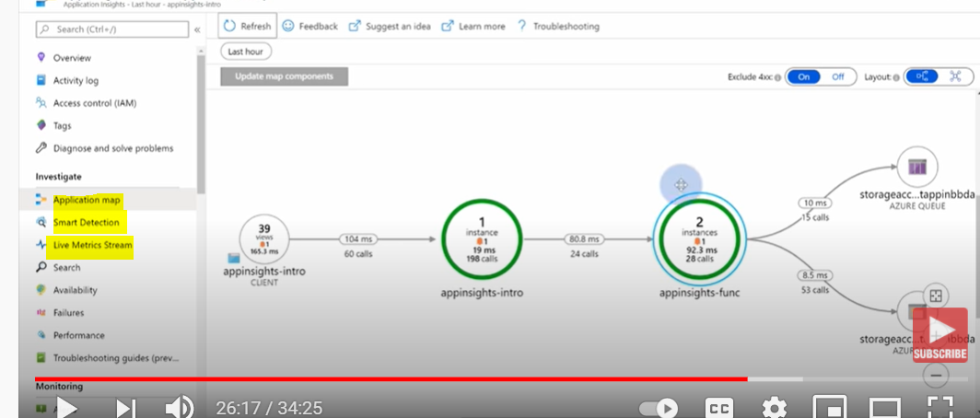

Where do I see my telemetry?

Smart detection and manual alerts
Set up automatic alerts that adapt to your app's normal patterns of telemetry and trigger when there's something outside the usual pattern. You can also set alerts on particular levels of custom or standard metrics.

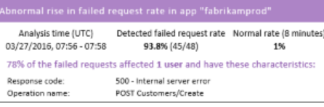

Application map
Explore the components of your app, with key metrics and alerts.

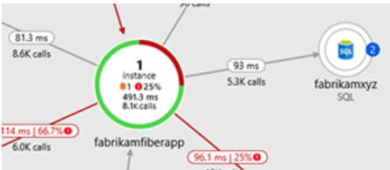

Profiler
Inspect the execution profiles of sampled requests.
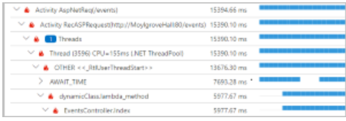

Usage analysis
Analyze user segmentation and retention.

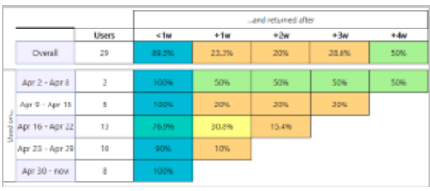

Diagnostic search for instance data
Search and filter events such as requests, exceptions, dependency calls, log traces, and page views.
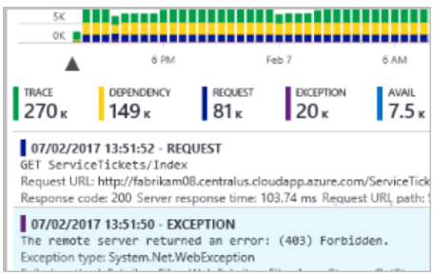

Metrics Explorer for aggregated data
Explore, filter, and segment aggregated data such as rates of requests, failures, and exceptions; response times, page load times.
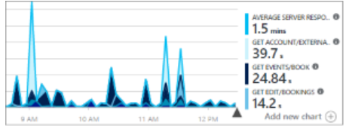
Dashboards
Mash up data from multiple resources and share with others. Great for multi-component applications, and for continuous display in the team room.
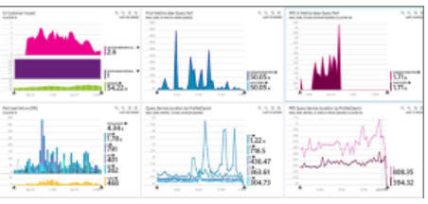
Live Metrics Stream
When you deploy a new build, watch these near-real-time performance indicators to make sure everything works as expected.
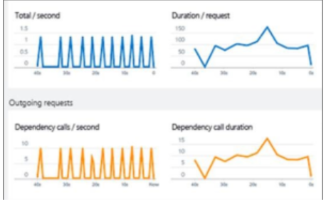

Analytics
Answer tough questions about your app's performance and usage by using this powerful query language.
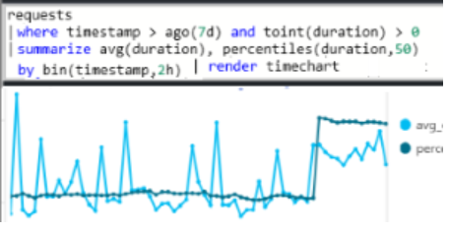

Visual Studio
See performance data in the code. Go to code from stack traces.
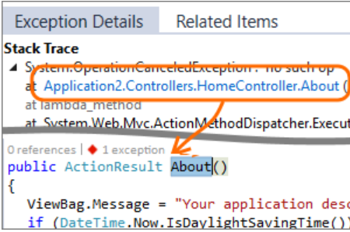

Snapshot debugger
Debug snapshots sampled from live operations, with parameter values.

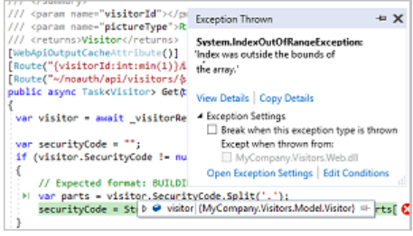
Power BI
Integrate usage metrics with other business intelligence.
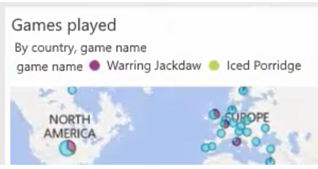

REST API
Write code to run queries over your metrics and raw data.
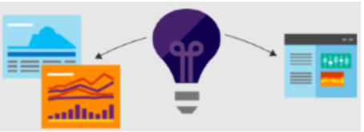

Continuous export
Bulk export of raw data to storage as soon as it arrives.
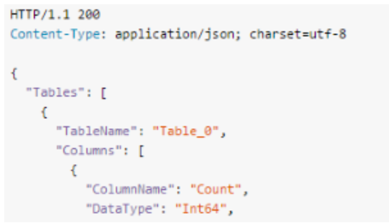

Azure Event Grid

Fully managed event routing service

Azure Event Grid allows for uniform event consumption using a publish-subscribe model allowing react to relevant events across both Azure and non-Azure services in near-real time fashion.

Event - What happened
Event source - Where the event took place
Topic – The endpoint where publishers send events
Event subscription – The endpoint or built-in mechanism to route events , sometimes to more than one handler
Event handler – The app or server reacting to the event

Events

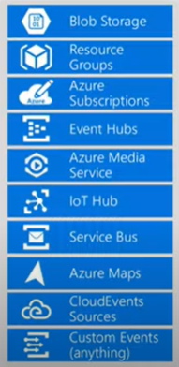



Event Handler
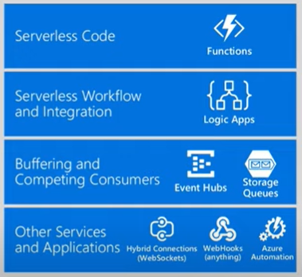

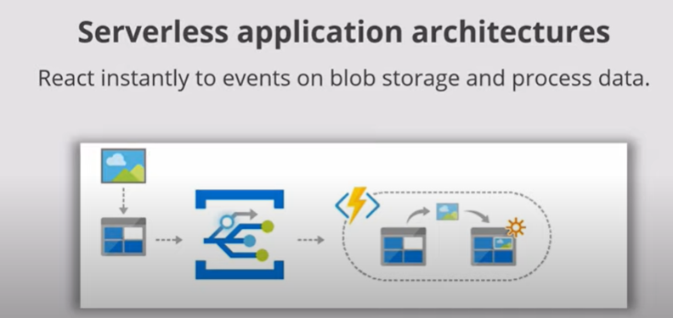

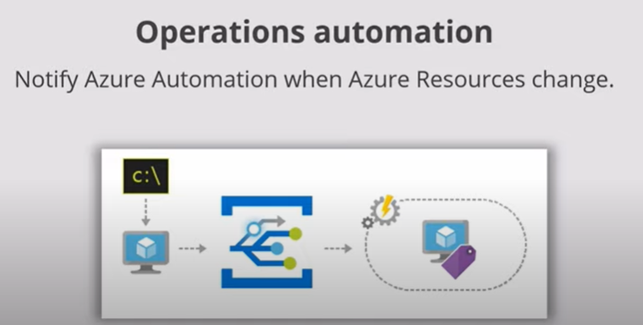
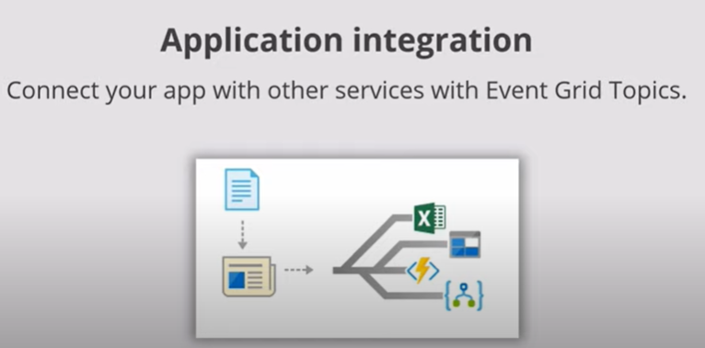

Key Benefits
Simplicity : Point and click to aim events from your Azure resource to any event handler or endpoint
Advanced Filtering : Filter on event type or event publish path to make sure event handlers only receive relevant events.
Fan-out : Subscribe several endpoints to the same event to send copies of the event to as many places as needed
Reliability : 24 hr retry with exponential backoff
Cost : 0.60 per 1,000,000 operations

Capabilities
Pay per event
High throughput
Built-in Events
Custom Events

Event grid has to be registered for the subscription
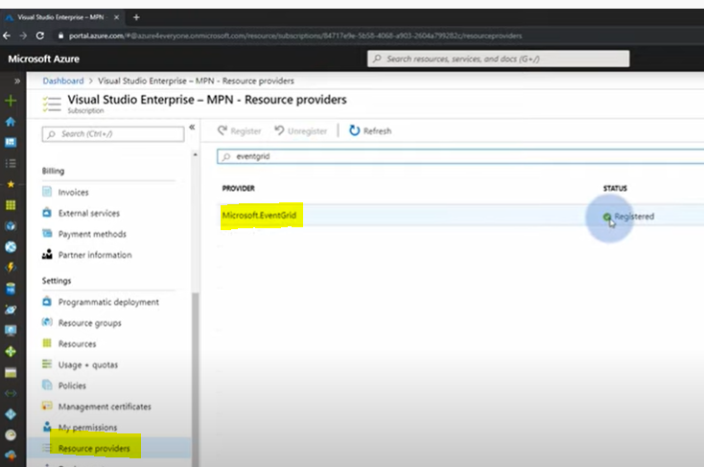

Logic App Trigger with event Blob created
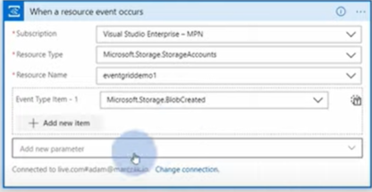

We can add further filter to get specific events , like a specific container

Custom Event – Event Grid Topic

Logic app to trigger this custom event
Publish event in Logic app to trigger this event
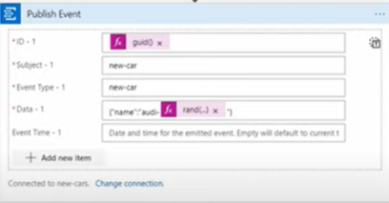

Listening to the Custom Event

Event grid topic Create event subscription

Web Hook Http trigger
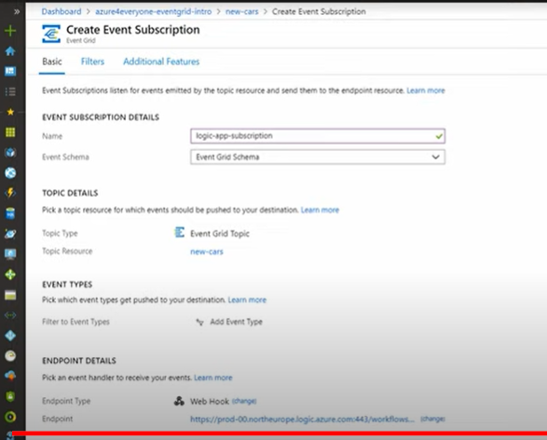



We can have multiple subscriptions for the event

Azure Event Grid allows you to easily build applications with event-based architectures. First, select the Azure resource you would like to subscribe to, and then give the event handler or WebHook endpoint to send the event to. Event Grid has built-in support for events coming from Azure services, like storage blobs and resource groups. Event Grid also has support for your own events, using custom topics.

